The Harbor Ridge Homeowner
A Publication of the Harbor Ridge Homeowners Association Spring 2009
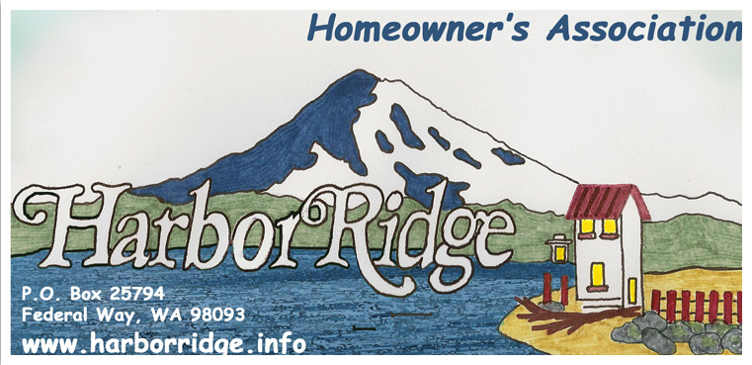
President - Henry Mayorga
Vice Pres. - Gail Neufeld
Secretary - Catherine Bixler
Treasurer - Dietrich Brunner
Trustee - Debbie Doran
Trustee - William Halls
Trustee - Richard Judy
Trustee - Ingrid Lincicome
Trustee - Doug Shook

2009 Board Meeting Schedule Spring Clean up at Harbor Ridge Main Entrances
June 24th Saturday May 9th at 10:00 AM
July 22nd Residents are invited to help plant flowers, add bark,
September 23rd pick up weeds, and repair sprinklers
October 28th
December 30th

Honoring Those Who Serve Us in Law Enforcement .... who also live with here and are an integral part of our Harbor Ridge Community. They include those below, as well as others who choose to remain anonymous, but whom we honor as well.

Ed Johnson is a Detective in the fugitive warrants division for the King County Sheriff Dept. He travels to other states to pick up fugitives that have King County felony warrants. He has been with the Dept. for more than 18 years. Before that he spent 20 years with the Seattle Police Dept. (16 years in patrol, two years in the harbor unit, and two years in the Mounted Patrol unit (horses).

He and his wife Roberta have been married for 40 years. They grew-up in West Seattle, met in high school and married in Ed’s senior year. Son Scott is a journeyman in construction, and daughter Kelli also works for the King County Sheriff Dept. …. as an I-D Tech (fingerprinting new bookings). Ed and Roberta’s two precious grandchildren (Erik and Cassidy) love sleepovers at Grandpa and Grandmas. Ed and Roberta moved to Harbor Ridge in 1999 (after spending 30 years in West Seattle), live on Harbor Ridge Road, and both love the Harbor Ridge neighborhood and the wonderful friends they have made. Their special interest include working in the yard, and going on cruises. They also enjoy exhibiting their (since high school) single-owner ‘54 Ford.

Advice for us: Keep track of cars in your neighborhood either parked (with occupants) or that are cruising through on a repeated basis.
------------------

Honoring Those Who Serve Us in Law Enforcement (continued)

Doug Shook is a Deputy with the Pierce County Sheriff's Dept./ University Place PD Detachment, currently assigned as the primary responding/investigative officer (School Resource Officer) for all 8 schools in U.P. During the summer, Doug transfers back to regular patrol duties.

Doug lived in numerous locations in Europe and in the U. S. while growing up, ending up here in Washington, having moved every few years while his father worked for the govt/military. Jennifer, on the other hand, is a Washington native, having lived in Tacoma most of her life, with a stay in Ellensburg for college. Doug and his wife Jennifer live on Harbor Ridge Road. They share special Interests including travel, skiing, and snorkeling, and their Shetland Sheepdog (Shelty)

Advice for us: Be smart about your property- don’t leave your cars and houses unlocked or garage doors open. Get a locking mailbox (or look into a secure group mailbox, like many already in our community). Shred any information about yourself that you throw out/recycle. Bad people come to the nicer neighborhoods to do their "shopping."
--------------------

Helen Stieben is assigned as the Community Liaison Officer for Northeast Tacoma for the Tacoma Police Department. Family is her major special interest, and to that she adds keeping physically fit. She and her husband John live on Harbor Ridge Road. Their four children Jonathan(13), Jarod (12), Maya (9), and Alisha (6) all attend our local schools.

Helen grew up in Tacoma and graduated from Lincoln High School. Her husband John is from Lewis County (Centralia area).

Advice for us: With police staffing in NE Tacoma better than it has been in the past, she especially encourages us not to hesitate to use 9-1-1 when in doubt, so that police response can be prompt. For crime and property reports, volunteers at the Police Substation (staffed weekdays from 9 a.m. to 9 p.m.) can help with the filing process, although many reports can also be submitted via the www.cityoftacoma.org web site.
------------------

Steve Woodard, is a Motorcycle Officer, a Master Motorcycle Instructor and a Primary Investigator on the Accident Investigation Team for the Tacoma Police Department. Steve met his wife Tammy at Boyce State College and they were married after he received his degree in Criminal Justice. Their daughter Amanda is a recent graduate from Gonzaga State University.

The Woodards, who live on Osprey Dr., like to spend weekends doing family activities, as a motorcycle enthusiast, Steve belongs to the National Motorcycle Club and participates in the club's annual event where 3500 to 5000 members meet for two weeks of fun activities.
Advice for us: We live in a safe community; take the time to meet and know your neighbors. It makes it easier if there is an emergency or if there are other circumstances where there is a need of our assistance. Small actions help to a safer community.

9-1-1 ... THINGS YOU SHOULD REALLY KNOW

When time is of the essence, whether because of a health, safety, or other emergency, the 9-1-1 system is ready to take your call and to dispatch the appropriate response personnel.

We have enclosed a brochure for your benefit. Please read it and retain it as a reference.

For issues that do not require rapid response, instead of 9-1-1, call the non-emergency number (253) 798-4721. You may have to stay on the line a while until there is a break in the 9-1-1 priority calls being handled.
-----------------------------

A RELATED ALERT: There has been a rash of recent home burglaries nearby, largely in the daytime when owners are absent. These have involved multiple individuals, in contact with one another. One remains in a car nearby as one or two others force entry to the home. If you suspect such an event is imminent or in progress in your neighborhood, do call 9-1-1.
-----------------------------

SAVE THE DATE - Tuesday August 4th -

NATIONAL NIGHT OUT in HARBOR RIDGE
Food, Music, Games, Fun - Meet your Neighbors
More information as the date approaches

Our condolences to the Bauwens, Silver Bow Rd. on the recent loss of their Daughter

